**Data Movement’s Follow the Sun (FTS) - Handoff Tool & Process**

**Guide for Assignment Leads**

What is an Assignment/Handoff Lead?

Team lead who is an assignment lead in VDM and/or manages the handoff call between regions.

This Guide assumes the following:

* You are an Assignment Lead active on VDM OR a handover lead who will be managing the handover call between your region and another.
* You’re familiar with the current [Big Data / Data Movement handoff process](https://dev.azure.com/Supportability/Big%20Data/_wiki/wikis/Big-Data.wiki/306262/Case-Handoff-Process)

Note for Assignment/Handover Leads

**Currently we have requested that our support engineers complete their FTS requests up to the “Ensure Summary” stage, and then leave it to the Leads to confirm and complete the transfer at the time of the handover call.**  
  
This is to ensure that our engineers correctly complete the transfer process and that they are moving valid transfers.  
  
**However, there is no mechanical reason that leads need to do this. Engineers can complete the process themselves.** Whenever you are comfortable with the quality of handovers at your handover call, please empower your engineers to complete the FTS transfer process themselves.  
  
It is suggested to do daily reviews for at least two weeks before phasing out lead reviews. However, use discretion for your own regions and handover calls.

How to Facilitate Transfer of FTS Cases  
Each of these steps has an explanatory section in the guide below.  
These steps should be completed just before or at the time of your handoff call.

1. Check the list of FTS requests in the next handover call.
2. If the FTS request is incomplete, reach out to the owning case engineer to confirm if a transfer is needed.
   1. If a transfer is needed, request that the engineer complete their FTS Request
   2. If a transfer is not needed, delete the request.
3. If the FTS request is completed up to the “Ensure Summary” stage, confirm that the transfer is a valid transfer.
   1. If a valid transfer, finish the transfer process by completing the “Assign Resource” and “All Done” stages.
   2. If not a valid transfer, discuss with owning engineer or previous region’s assignment lead to confirm how to handle the case.

How to Access the FTS Tool and Handover Call Menu

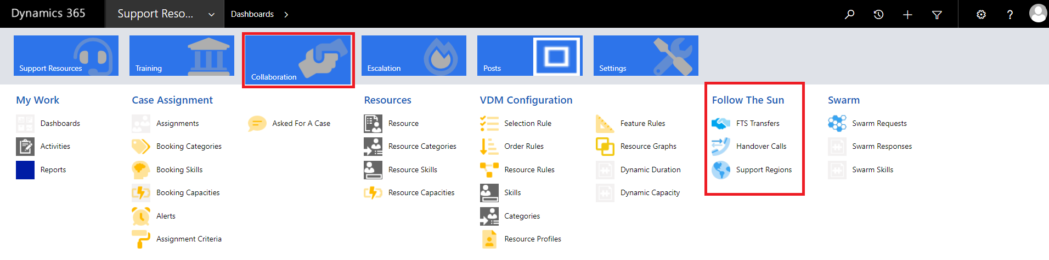

1. In Edge Browser:  [https://crmglobal.corp.microsoft.com/GLBCRMSUP/](https://crmglobal.corp.microsoft.com/GLBCRMSUP)
2. Go to **Collaboration**, then **FTS Transfers** under “**Follow The Sun**” title
3. Select “Handover Calls”  
   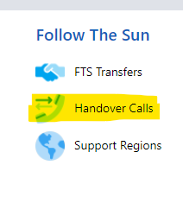
4. Search “Data Movement”
5. Choose your next handover call.  
   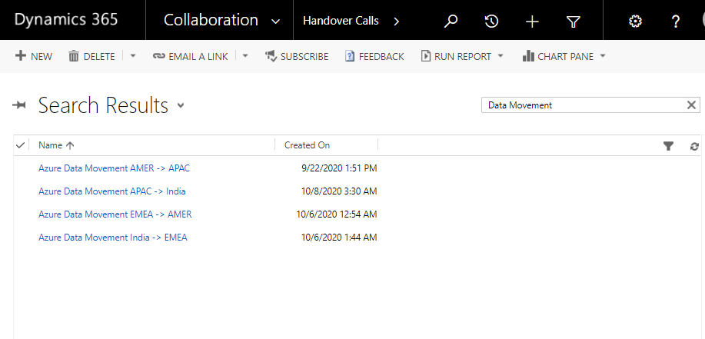

Handover Call Menu

In this menu you can see all the FTS transfer requests.  
  
These requests are added by one of two methods.  
1. Automatically – Based on Severity and Status, FTS will automatically create a request.

2. Manually – An engineer creates a transfer request for their case.  
  
Below is a description of all the parts of the handover menu.

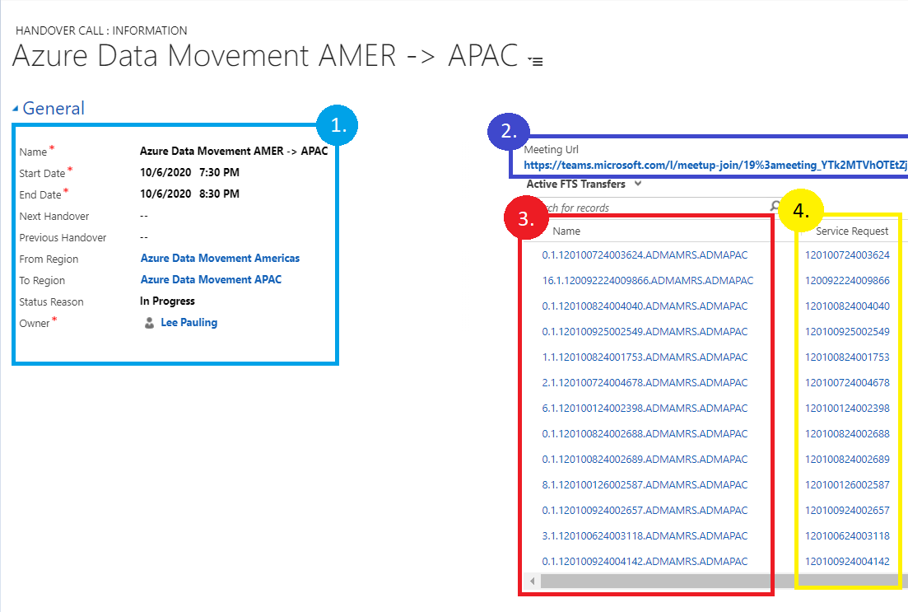

* 1. General handover call time and information.
  2. Handover meeting URL. (This is a link to our existing handover teams meetings.)
  3. Links to the FTS requests for each case.
  4. Service request number associated with each case.

To modify/update an FTS request, select the link to the FTS request for your case number.

Cases Automatically Added to FTS

Cases that meet the criteria below will be automatically added to the FTS list to be approved for transfer.

* Sev A “CritSit” cases not marked as “Waiting for Confirmation”
* Sev B and 27x7 flagged cases not marked as “Waiting for Confirmation”

Since the support engineer did not create this request themselves, the case may not need handover. Confirm with the engineer if case needs handover and have them modify their status and/or severity so it accurately reflects current case status. Then delete or deactivate FTS request.

Delete/Deactivate Unnecessary Transfer Request

To delete an unnecessary transfer request, select the “Delete” icon at the top of the page. Deleting the request will remove it entirely and all work will be lost.

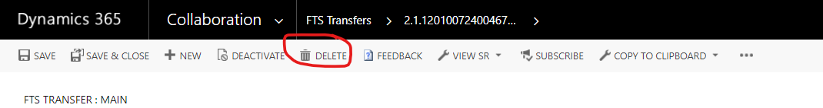

To deactivate an unnecessary transfer request, select the “Deactivate” icon at the top of the page. Deactivating a request will remove it from the FTS transfer list on your handoff call, but will not delete the request, which can be re-activated at any time.



Complete an FTS Transfer Request

1. At the handover call time, you will review all transfer requests in your handover call and either approve or remove them. Once you have approved a transfer, you will need to complete the last two steps: select a resource and process the transfer.   
   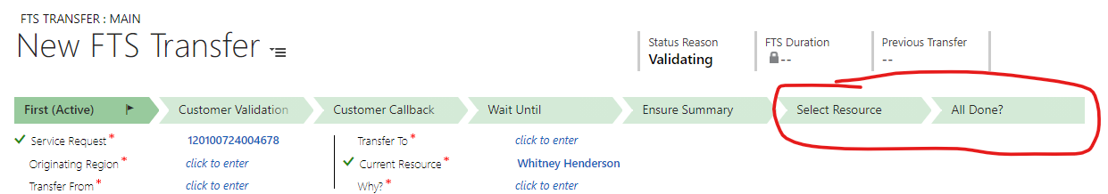

1. Under “Select Resource” there are three options to choose a resource in the next region.  
   a. Automatic – The option you will most often use. Automatic uses VDM to choose the next engineer available in the region you are transferring to. It favors engineers who have owned the case in the past.  
   b. Manual – allows you to manually choose an engineer to assign to in the next region.  
   c. Skip – Allows the transfer to skip the current region and move on to the next. For more information, see the “How to Skip a Region” section.  
     
   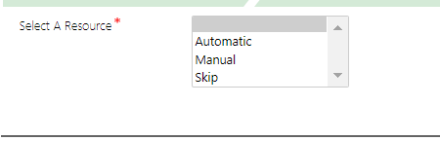
2. After all other fields have been filled out, select “Finish” in the All Done stage. This will initiate the transfer at the time of the handover call.  
   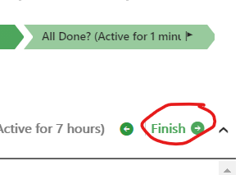

How to Skip a Region in FTS

Let us say, for example, you have a case in AMER that needs to skip APAC and go straight to EMEA.  
You can use FTS to perform this transfer.  
  
1. You fill out your FTS transfer as normal, and in the “Transfer To” section, you pick THE NEXT REGION. Choose the next handover call and the next region, as the case will still need to pass through that region to get to the region you need. So for our example, you would still choose “APAC” as the next region, and the APAC handover call as the next handover call.  
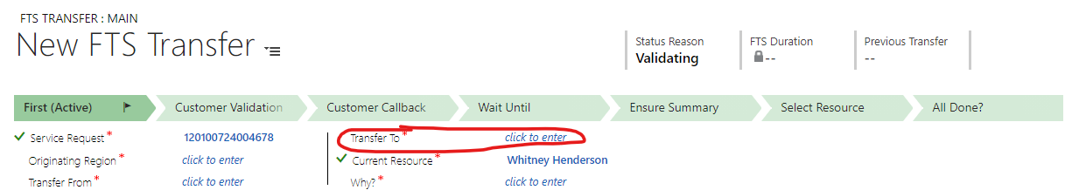  
  
2. Fill out the rest of the transfer as normal, and in the summary notes specify that the case needs to skip a region and why.  
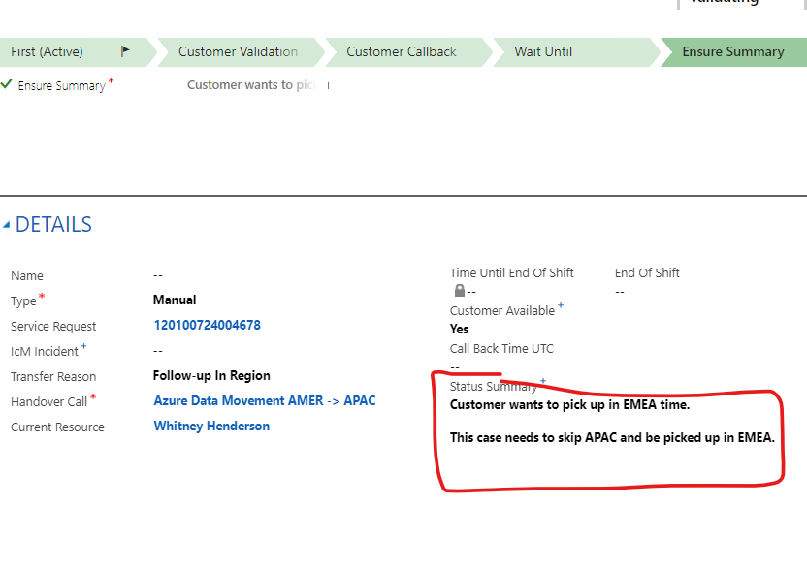  
  
3. Then in the “Select Resource” Section the Lead will see that the case needs to skip the region and choose “Skip”. The transfer will then skip the region and be moved to the next, where the leads can choose to process the assignment for that region.

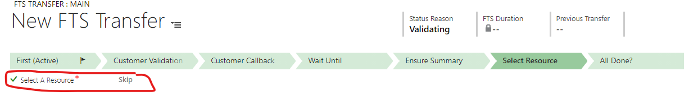

Troubleshooting

Can’t Update Your FTS Request?  
  
Issue:  
You cannot update your FTS Request, can’t save it, and your stages show little lock icons.  
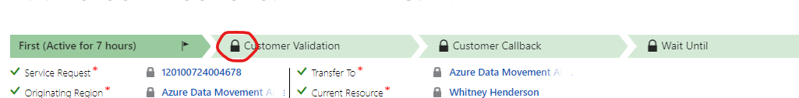  
Resolution:  
Your FTS request is inactive. You can see this at the bottom of the page.  
Select “Activate” to continue working on your FTS request.  
